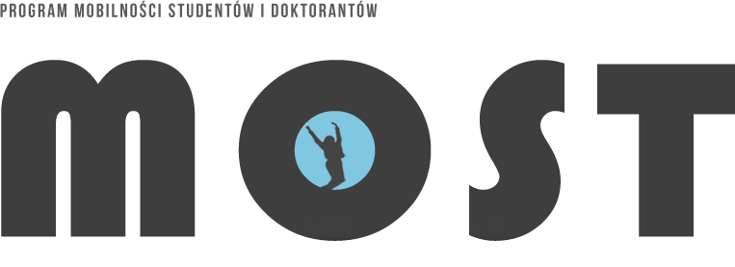

„MOST” STUDENT AND DOCTORAL STUDENT MOBILITY

PROGRAMME
Admission for the winter semester and for the entire academic year 2021/2022
- Create an account or log in to IRK MOST system (https://irkmost.amu.edu.pl/pl/)
- Select the course(s) at the university where you wish to pursue the MOST exchange program.
REMEMBER !!! about keeping your priorities in choosing your fields of study.
- Generate an application.
- Printed and signed application should be scanned and sent to
the email address of the University of Szczecin Coordinator. e-mail: ewa.czerwinska@usz.edu.pl
- If you choose to include a cover letter with your application, you should also print it out, sign it, and send it as a scan along with your application to the email address listed above.
- The University of Szczecin Coordinator will inform you of the receipt of your application (cover letter) by return email, which is the confirmation of your application.
- The application will then be submitted to the competent Deputy-Dean for Student Affairs and the Deputy- Rector for Student Affairs for approval.
- A student will be notified by the University of Szczecin Coordinator in an email if the student receives an approval.

- The approval of applications will be uploaded to the IRK system and presented to the University Education Committee.

- Decisions of the University Education Committee will be available on individual student accounts in the IRK program.

AFTER QUALIFYING FOR THE “MOST” PROGRAMME, A STUDENT IS OBLIGED TO SIGN THE CURRICULUM AGREEMENT. IN ORDER TO OBTAIN ASSISTANCE IN CREATING SUCH AN AGREEMENT, PLEASE CONTACT THE FACULTY COORDINATORS OF THE UNIVERSITY OF SZCZECIN.
http://studenci.usz.edu.pl/kontakt-most/

